

Project Name: Company Green Meter

 | Team Members | UB IB
1) | Aswathi Nambiar | 5024 5596
2) | Milind Nandankar | 5024 6442
3) | Akshaya Naik | 5022 6723
4) | Aashna Mockul | 5024 6926

Business Requirements Document (BRD)

Version and Approvals

Version History
Version # | Date | Revised By | Reason for change
0.1 | 11/30/17 | Aswathi Nambiar
0.2 | 12/23/17 | Akshaya Naik

Document Approvals
Approver Name | Project Role |  | Signature/Electronic Approval | Date

Table of Contents

Project Name: Company green meter i

Version and Approvals ii

1. Project Details 2

2. Document Resources 2

3. Glossary of Terms 2

4. Project Overview 3
4.1 Project Overview and Background 3
4.2 Project Dependencies 3
4.3 Stakeholders 3

5. Use Cases 3
5.1 Use Case Description 3

6. Data Information 8

- Project Details

Project Name | Company Green Meter
Project Type | New Initiative
Project Start Date | October 2017
Project End Date | December 2017
Project Sponsor
Primary Driver | DBMS related project
Secondary Driver
Division

- Document Resources

Name | Business Unit | Role
Aswathi Nambiar
Akshaya Naik
Aashna Mockul
Milind Nandankar

- Glossary of Terms

Term/Acronym | Definition

- Project Overview

Project Overview and Background

Today's entrepreneurs understand the value of making positive environmental impacts through their businesses more than ever before. Making a green impact as an organization can strengthen customer relationships and help to build a brand image of integrity and a commitment to ethics. However, it can be challenging to quantify and measure the green impact of a business, especially when a company contributes to environmental protection in more than one way. Learning how to creatively measure the positive environmental impact your company makes can help you to benchmark your own progress while providing data and statistics useful for marketing and public relations campaigns.

Company Green Meter is an initiative which will help the organizations to measure how they are affecting the environment and to rate the organizations based on their green initiative measures. In the Database Management System, the companies will be categorized based on their respective domains for e.g. Healthcare, Banking & Finance, and Retail etc. In any organization irrespective of the domain, there are some common wastes, which are produced on a daily basis. Each company’s green impact will be measured based on the below five Categories.

- Dining Wastage
- Transport
- Facilities
- Recreation

The companies within a particular domain will be given a calculated rank on the basis of the above four measures.

Companies should implement the Green Meter initiative to improve business performance and the bottom line. For instance, companies will set objectives in order to reduce energy consumption and ultimately reduce cost.

Project Dependencies
N/A

4.3 Stakeholders
The following comprises the internal and external stakeholders whose requirements are presented in this document:

No | Stakeholders
1. | Board of Directors of the Organization
2. | Senior Management of the Organization

- Use Cases

Use Case Description

    - Data Collection

The data will be collected from the companies in the form of excel sheets, survey forms, questionnaires pertaining to the attributes in different categories. There will be different form/questionnaire for different categories. The company can choose how they want to provide us with the data. The survey will consists of multiple choice, Yes/No or one word answer questions. For example for Facilities category Q: Enter the electricity consumption bill in $ for the month of MAY?

We will be considering the below six domains.

- Manufacturing
- Healthcare
- Finance
- Information Technology
- Retail
- Ecommerce

    - REPORTS

The following reports will be generated

Use Case # | UC.1
Use Case Description | Domain based report of the Company
Detailed Description | The report is generated based on the domain of the companies. This report will help us to understand which domain type are mostly involved in green initiative, which will further help us to target the specific type of domains in future.
Constraints and Assumptions

Use Case # | UC.2
Use Case Description | Company based report
Detailed Description | This will contain information about how each company is doing in terms of the food wastage, fuel consumption, facilities, and re-creation.
Constraints and Assumptions

Use Case # | UC.3
Use Case Description | Category wise report
Detailed Description | This report will contain information on how the specific category is performing compared to other categories
Constraints and Assumptions

Use Case # | UC.4
Use Case Description | Top 10 Company report
Detailed Description | This report will contain the Top 10 companies and their corresponding score for the month.
Constraints and Assumptions

Use Case # | UC.5
Use Case Description | Bottom 10 Company report
Detailed Description | This report will contain the Bottom 10 companies and their corresponding score for the month.
Constraints and Assumptions

Use Case # | UC.6
Use Case Description | Every company-every category report
Detailed Description | This report contains the comparison of one department company wise for the month i.e. the company’s performance in that particular category for the entire month.
Constraints and Assumptions

Use Case # | UC.7
Use Case Description | Company Strength vs Weakness report
Detailed Description | This report contains the information about the category in which the companies is doing a lot of progress vs category in which the company needs to put a lot of effort and focus on.
Constraints and Assumptions

- Data Information

The various entities imperative for support of the use cases.

Domain | Represents the domain in which each organization belongs. For example, Healthcare, Finance, Retail etc. Domain table will contain the Domain-ID and Domain Name.
Company | Company is the entity on which the data is collected. Company will consists of Company ID, Company Name, Domain ID, and Number of employees.
Dining | Dining table will consists of the details of the food wastage in kilograms by each company. It consists of Company ID, Date of data collection, Food Consumption, Food Wastage.
Transport | Fuel Consumption will consists of the details of the amount of fuel consumed by the company in the Transport services. The table will consist of Company ID, Date of data collection, Fuel consumption in liters, number of employees travelled.
Green Budget | Recreation is how much budget the company is allocating to the green initiatives organized in the company. Recreation will consists of company ID, date of the data collection, Green Budget in dollars.
Facilities | Facilities includes the electricity usage, water consumption, paper use by the organization.
Department Rank History | This table will contain a history of the company rank according to the department.
Company Rank History | This table will contain the company rank history irrespective of their domains.

ENTITY RELATIONSHIP DIAGRAM

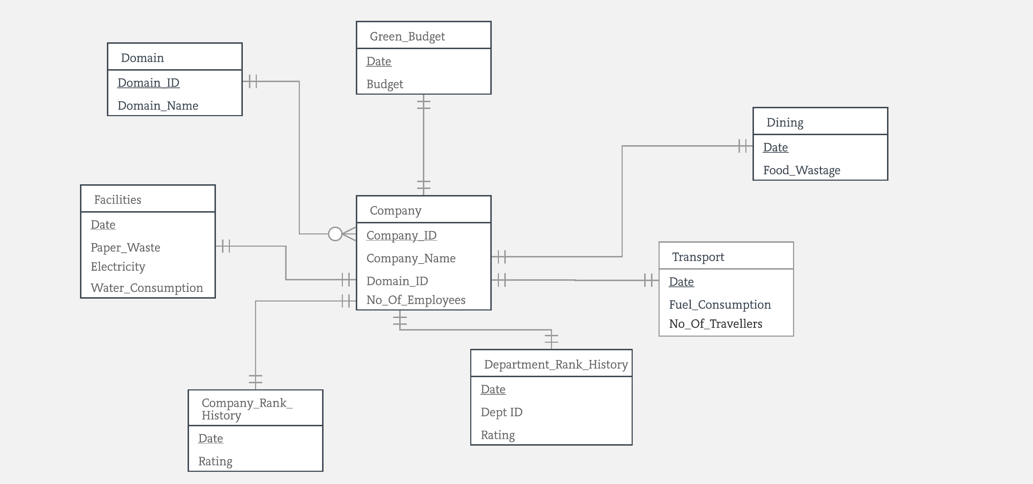

LOGICAL SCHEMA

DOMAIN
DOMAIN_ID | DOMAIN_NAME

COMPANY
COMPANY_ID | COMPANY_NAME | DOMAIN_ID | NO_OF_EMP

DEPARTMENT_RANK_HISTORY
COMPANY_ID | DEPARTMENT_ID | DATE | RANK

COMPANY_RANK_HISTORY
COMPANY_ID | DATE | RANK

DINING
COMPANY_ID | DATE | FOOD_WASTAGE(KG)

TRANSPORT
COMPANY_ID | DATE | FUEL_CONSUMPUTION ( LITRES) | NO_OF_EMPTRAVELLED

GREEN_BUDGET
COMPANY_ID | DATE | BUDGET

FACILITIES
COMPANY_ID | DATE | PAPER_USED(KG) | ELECTRICITY($) | WATER_CONSUMPTION($)

CREATE STATEMENTS

CREATE TABLE Domain
(Domain_ID VARCHAR2(10) NOT NULL,
Domain_Name VARCHAR2(40) NOT NULL,
CONSTRAINT Domain_PK PRIMARY KEY (Domain_ID));

CREATE TABLE Company
(Company_ID VARCHAR2(10) NOT NULL,
Company_Name VARCHAR2(40) NOT NULL,
Domain_ID VARCHAR2(10),
No_of_emp NUMBER,
CONSTRAINT Company_PK PRIMARY KEY (Company_ID),
CONSTRAINT Company_FK FOREIGN KEY (Domain_ID) REFERENCES Domain(Domain_ID));

CREATE TABLE Department_rank_history
(Company_ID VARCHAR2(10) NOT NULL,
Department_ID VARCHAR2(10) NOT NULL,
Date_ DATE NOT NULL,
Rank_ NUMBER,
CONSTRAINT DeptRank_PK PRIMARY KEY (Company_ID, Department_ID, Date_),
CONSTRAINT DeptRank_FK FOREIGN KEY (Company_ID) REFERENCES Company(Company_ID));

CREATE TABLE Company_rank_history
(Company_ID VARCHAR2(10) NOT NULL,
Date_ DATE NOT NULL,
Rank_ NUMBER,
CONSTRAINT CompanyRank_PK PRIMARY KEY (Company_ID, Date_),
CONSTRAINT CompanyRank_FK FOREIGN KEY (Company_ID) REFERENCES Company(Company_ID));

CREATE TABLE Dining
(Company_ID VARCHAR2(10) NOT NULL,
Date_ DATE NOT NULL,
Food_wastage_kg NUMBER,
CONSTRAINT Dining_PK PRIMARY KEY (Company_ID, Date_),
CONSTRAINT Dining_FK FOREIGN KEY (Company_ID) REFERENCES Company(Company_ID));

CREATE TABLE Transport
(Company_ID VARCHAR2(10) NOT NULL,
Date_ DATE NOT NULL,
Fuel_consumption_litres NUMBER,
No_of_emptravelled NUMBER,
CONSTRAINT Transport_PK PRIMARY KEY (Company_ID, Date_),
CONSTRAINT Transport_FK FOREIGN KEY (Company_ID) REFERENCES Company(Company_ID));

CREATE TABLE Green_budget
(Company_ID VARCHAR2(10) NOT NULL,
Date_ DATE NOT NULL,
Budget NUMBER,
CONSTRAINT GreenBudget_PK PRIMARY KEY (Company_ID, Date_),
CONSTRAINT GreenBudget_FK FOREIGN KEY (Company_ID) REFERENCES Company(Company_ID));

CREATE TABLE Facilities
(Company_ID VARCHAR2(10) NOT NULL,
Date_ DATE NOT NULL,
Paper_used_kg NUMBER,
electricity_$ NUMBER,
water_consumption_$ NUMBER,
CONSTRAINT Facilities_PK PRIMARY KEY (Company_ID, Date_),
CONSTRAINT Facilities_FK FOREIGN KEY (Company_ID) REFERENCES Company(Company_ID));

FINAL QUERIES

The DEPARTMENT_RANK_HISTORY is populated by taking the individual ranks of each of the DINING, TRANSPORT, FACILITIES AND GREEN BUDGET table.
The following query is used to insert data into the DEPARTMENT_RANK_HISTORY table for the month of November.

DINING
Insert Into DEPARTMENT_RANK_HISTORY
Select Company_Id, '1', '01-Nov-17', Rank() Over(Order By W_Per_Capita) As Rank_ From (Select C.Company_Id, (W.Sum_Wastage/C.No_Of_Emp) As W_Per_Capita From (Select Company_Id, Sum(Food_Wastage_Kg) As Sum_Wastage From Dining D Where Date_ Between '01-Nov-17' And '30-Nov-17'
Group By Company_Id Order By Company_Id) W Inner Join Company C On C.Company_Id=W.Company_Id);

TRANSPORT
Insert Into Department_Rank_History
Select Company_Id, '2', '01-Nov-17', Rank() Over(Order By T_Per_Capita) As Rank_ From (Select C.Company_Id, (T.Sum_Fuel/C.No_Of_Emp) As T_Per_Capita From (Select Company_Id, Sum(Fuel_Consumption_Litres) As Sum_Fuel From Transport T Where Date_ Between '01-Nov-17' And '30-Nov-17'
Group By Company_Id Order By Company_Id) T Inner Join Company C On C.Company_Id=T.Company_Id);

GREEN BUDGET
Insert Into Department_Rank_History
Select Company_Id, '3', '01-Nov-17', Rank() Over(Order By G_Per_Capita) As Rank_ From
(Select C.Company_Id, (G.Sum_Budget/C.No_Of_Emp) As G_Per_Capita From (
Select Company_Id, Sum(Budget) As Sum_Budget From Green_Budget G Where Date_ Between '01-Nov-17' And '30-Nov-17'
Group By Company_Id Order By Company_Id) G Inner Join Company C On C.Company_Id=G.Company_Id);

FACILITIES
Insert Into Department_Rank_History
Select Company_Id, '4', '01-Nov-17', Rank() Over(Order By W_Per_Capita) As Rank_ From
(Select Company_Id, (Rank() Over(Order By W_Per_Capita_Paper) + Rank() Over(Order By W_Per_Capita_Elec) + Rank() Over(Order By W_Per_Capita_Water)) As W_Per_Capita
From
(Select C.Company_Id, (W.Sum_Paper/C.No_Of_Emp) As W_Per_Capita_Paper, (W.Sum_Elec/C.No_Of_Emp) As W_Per_Capita_Elec, (W.Sum_Water/C.No_Of_Emp) As W_Per_Capita_Water From
(Select Company_Id, Sum(Paper_Used_Kg) As Sum_Paper, Sum(Electricity_$) As Sum_Elec, Sum(Water_Consumption_$) As Sum_Water From Facilities D Where Date_ Between '01-Nov-17' And '30-Nov-17'
Group By Company_Id Order By Company_Id) W Inner Join Company C On C.Company_Id=W.Company_Id));

QUESTIONS :

- Display the RANKS of the Companies without using the function RANK() or DENSE_RANK()

Select A.Company_Id, A.Company_Name, Rownum Rank_
From (Select C.Company_Id, C.Company_Name, Avg(D.Rank_) As Average_Rank From Department_Rank_History D Inner Join Company C On D.Company_Id = C.Company_Id
Group By C.Company_Id,C.Company_Name Order By Avg(D.Rank_) ) A;

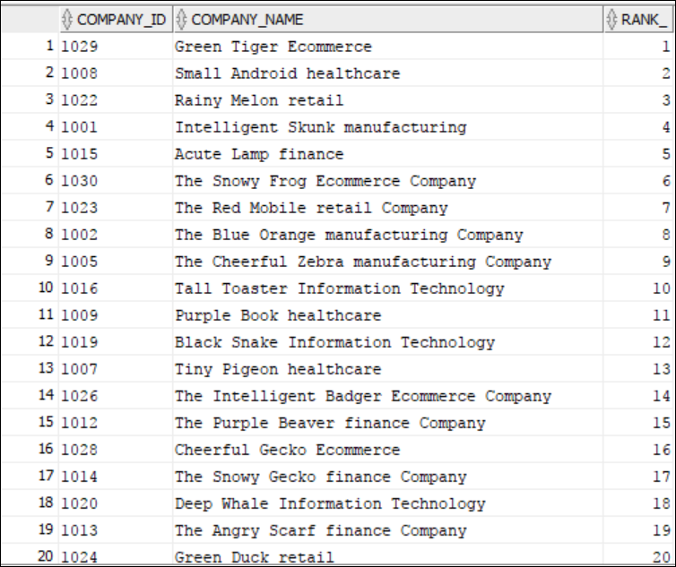

- Use LEAD() and LAG() feature for the companies RANKS according to the dates without using the LEAD() and LAG() function

select COMPANY_ID, date_, rank_,(select rank_ from COMPANY_RANK_HISTORY H2 where H2.COMPANY_ID=R.COMPANY_ID AND H2.date_=R.NEXTMONTH) as futurerank,
(select rank_ from COMPANY_RANK_HISTORY H2 where H2.COMPANY_ID=R.COMPANY_ID AND H2.date_=R.PREVMONTH) as pastrank
FROM
(Select COMPANY_ID, date_, rank_, ADD_MONTHS(Date_,1) as nextmonth, ADD_MONTHS(Date_,-1) as PREVmonth from COMPANY_RANK_HISTORY H1 order by COMPANY_ID, date_
)R;

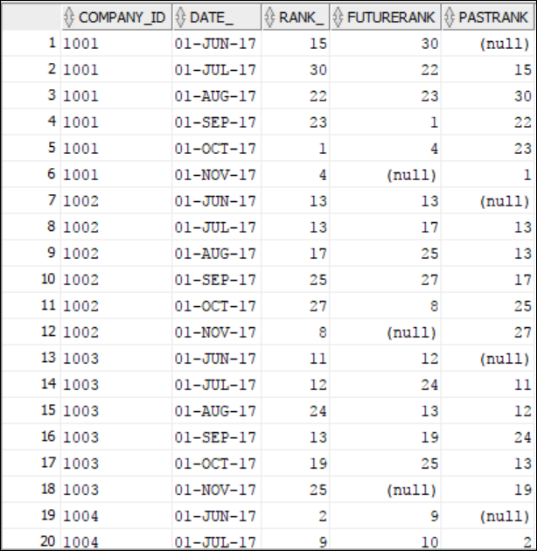

- Display the RANKS of the Companies by using RANK() function

Select A.Company_Id, A.Company_Name, Rank() Over(Order By Average_Rank) As Rank_Company From(
(Select C.Company_Id, C.Company_Name, Avg(Rank_) As Average_Rank From Department_Rank_History D Inner Join Company C On D.Company_Id = C.Company_Id
Group By C.Company_Id,C.Company_Name Order By C.Company_Id)A);

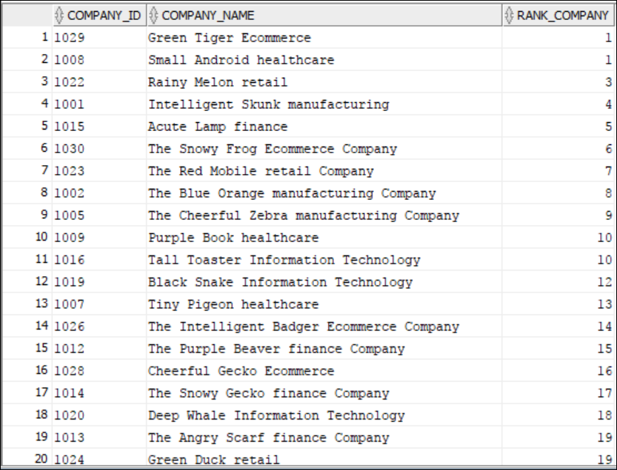

- Use LEAD() and LAG() function for the companies RANKS according to the dates.

Select C1.Company_Id,C.Company_Name,C1.Date_,C1.Rank_, Lead(C1.Rank_,1) Over(Partition By C1.Company_Id Order By C1.Date_) "Future Rank",Lag(C1.Rank_,1)
Over(Partition By C1.Company_Id Order By C1.Date_) "Previous Rank"
From Company_Rank_History C1 Inner Join Company C On C1.Company_Id = C.Company_Id ;

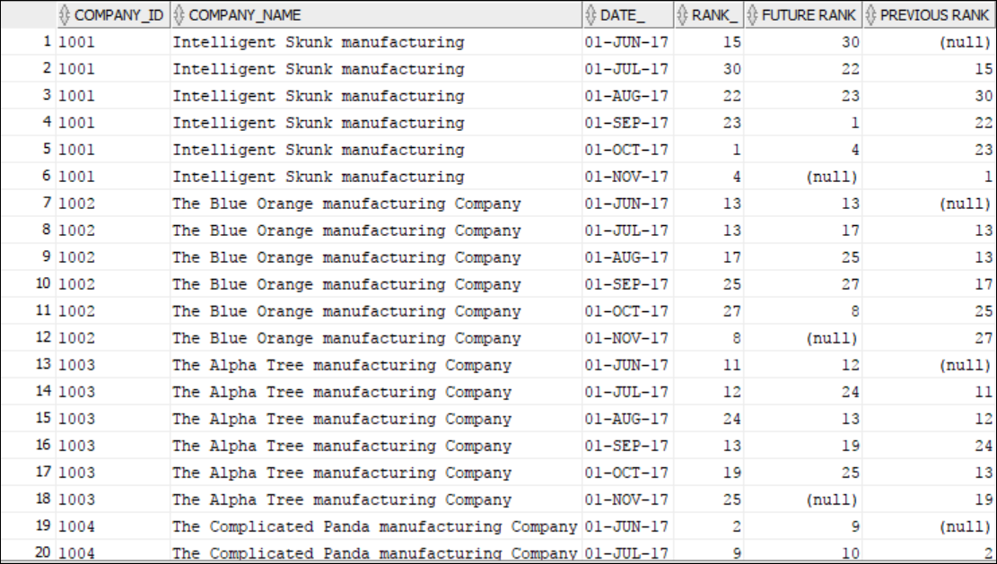

- COMPARE the above queries with and without the use of functions.

The Oracle Optimizer is a cost based optimizer. It selects the best execution plan for the query. The plan selected, often has the lowest cost. The lower the cost the better is the performance expected to be.

On the basis of this feature of the Oracle Optimizer, we have compared the performance of our queries on the basis of the cost and hence the resources which will be used by the queries.

The ‘Cost’ column indicates the cost of the plan in one round of execution.

Cardinality is one of the factors which determines performance. Cardinality is the number of rows each step will return. The higher the cardinality, greater is the work to be performed by the query.

Thus, higher the cardinality, higher the resource requirement, higher the cost.

The query with the rank() function uses more resources in terms of memory than the query which does not use the rank function. Although the CPU usage for both the queries is almost identical.
- RANK with the use of RANK() function
Here we can see that the Total cost is 46 i.e the %CPU is 46
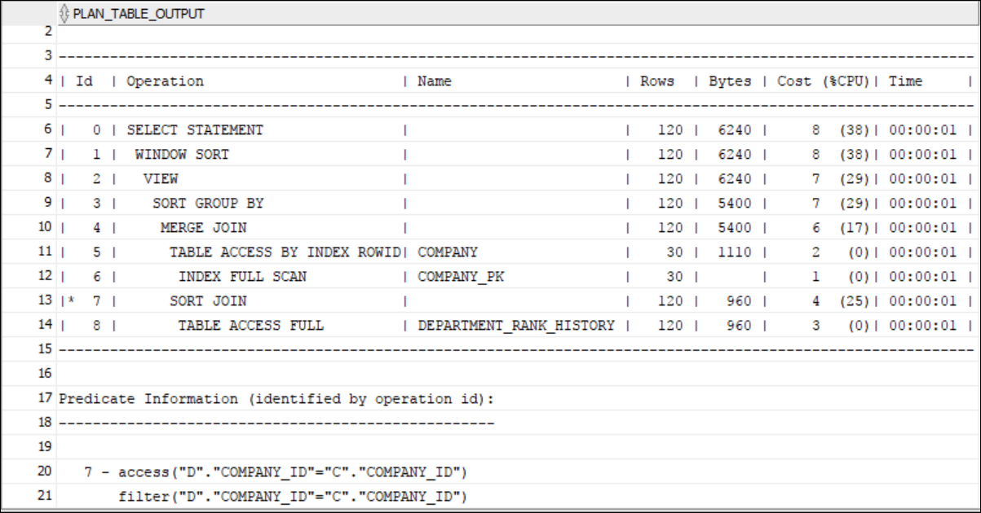

- RANK without function
Here we can see that the %CPU is 48
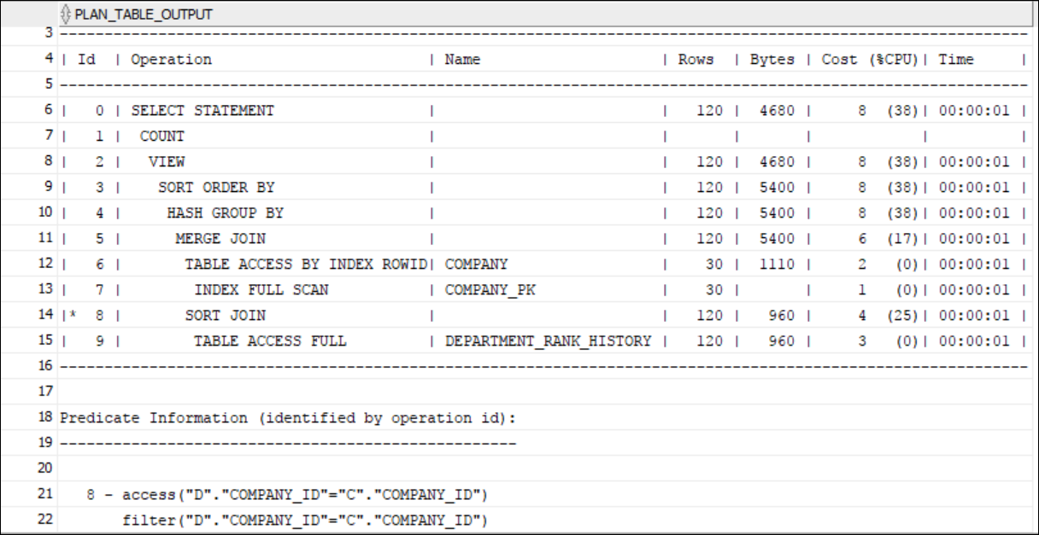

On a similar note, the CPU resources used by the lead/lag functions and queries without these functions is almost identical.

The memory resources used by the query with the lead/lag function is higher than that used by the query without the lead/lag function.

- LEAD(), LAG() using function
Here, we can see that the %CPU is 7

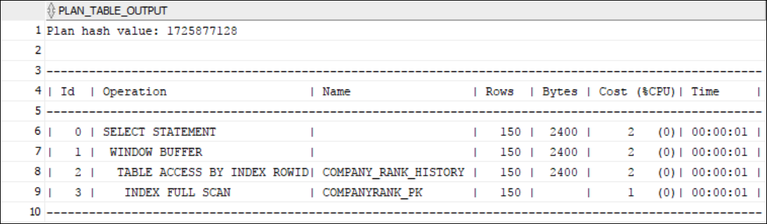

- LEAD(), LAG() without the use of functions
Here, we can see that the %CPU is 7

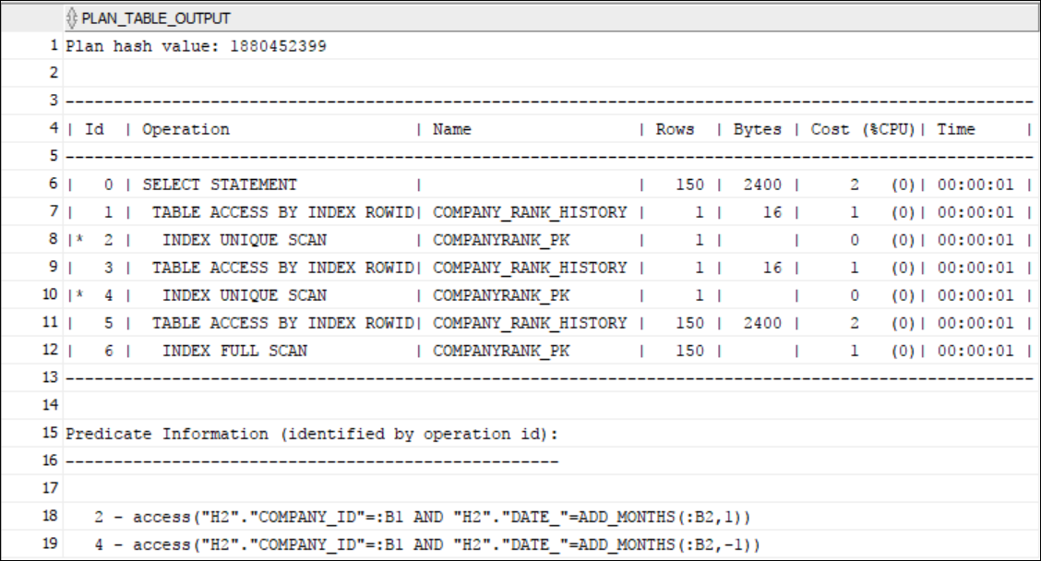

Thus, we can see that the queries with the rank/lead/lag functions will use more resources than the queries without these functions and therefore will be more costly.

This indicates that the performance of queries without the functions will be better than the performance of the queries without the functions.

- Display the Company and its previous rank history along with its Final Rank
Select A.Company_Id, A.R1, A.R2, A.R3, A.R4, Dense_Rank() Over(Order By Avg_Rank) As Final_Rank From (Select R.Company_Id, R.R1 , R.R2, R.R3, R.R4, ((R.R1 + R.R2 + R.R3 + R.R4)/4) As Avg_Rank From (Select Company_Id,
Max( Decode( Date_ , D.Latest_Date , Rank_ ) ) As R1,Max( Decode( Date_ , Add_Months(D.Latest_Date, -1) , Rank_ ) ) As R2,Max( Decode( Date_ , Add_Months(D.Latest_Date, -2) , Rank_ ) ) As R3,Max( Decode( Date_ , Add_Months(D.Latest_Date, -3) , Rank_ ) ) As R4
From Company_Rank_History, ((Select Max(Date_) As Latest_Date From Company_Rank_History)) D Group By Company_Id Order By 1) R) A;

